**Goa**

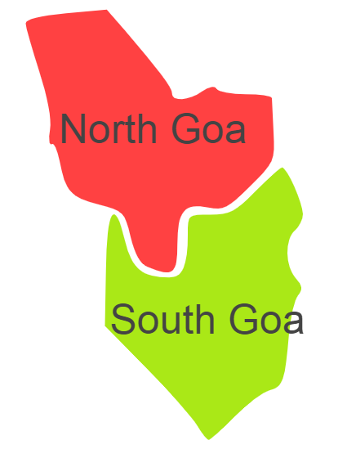

Goa comprises of one Agro Ecological Region (AER)19.

**Agro-Eco Region 19 :** AER 19 in Goa comprises of North Goa, South Goa districts of Western Ghats & Coastal Plain under Agro Ecological Sub Regions (AESR) 19.2 and 19.3.